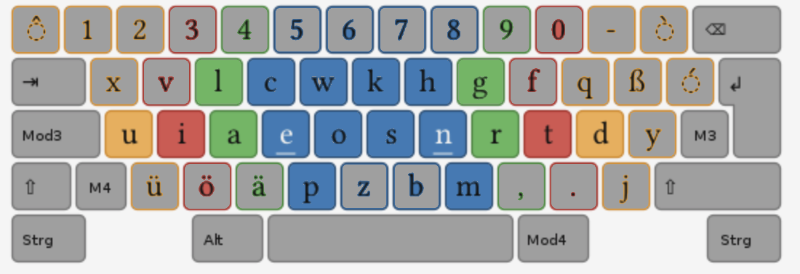epe nmn epe nmn epe nmn epe nmn epe nmn epe nmn epe nmn epe nmn epe nmn epe nmn

epe nmn epe nmn epe nmn epe nmn epe nmn epe nmn epe nmn epe nmn epe nmn epe nmn

epe nmn epe nmn epe nmn epe nmn epe nmn epe nmn epe nmn epe nmn epe nmn epe nmn

epa nmr epa nmr epa nmr epa nmr epa nmr epa nmr epa nmr epa nmr epa nmr

epa nmr epa nmr epa nmr epa nmr epa nmr epa nmr epa nmr epa nmr epa nmr

epi nmt epi nmt epi nmt epi nmt epi nmt epi nmt epi nmt epi nmt epi nmt epi nmt

epi nmt epi nmt epi nmt epi nmt epi nmt epi nmt epi nmt epi nmt epi nmt epi nmt

epu nmd epu nmd epu nmd epu nmd epu nmd epu nmd epu nmd epu nmd epu nmd

epu nmd epu nmd epu nmd epu nmd epu nmd epu nmd epu nmd epu nmd epu nmd

upe dmn upe dmn upe dmn upe dmn upe dmn upe dmn upe dmn upe dmn upe dmn

upe dmn upe dmn upe dmn upe dmn upe dmn upe dmn upe dmn upe dmn upe dmn

ipe tmn ipe tmn ipe tmn ipe tmn ipe tmn ipe tmn ipe tmn ipe tmn ipe tmn ipe tmn ipe tmn

ipe tmn ipe tmn ipe tmn ipe tmn ipe tmn ipe tmn ipe tmn ipe tmn ipe tmn ipe tmn ipe tmn

ape rmn ape rmn ape rmn ape rmn ape rmn ape rmn ape rmn ape rmn ape rmn ape rmn

ape rmn ape rmn ape rmn ape rmn ape rmn ape rmn ape rmn ape rmn ape rmn ape rmn